St Pius X Catholic Parish Heidelberg West acknowledges the Wurundjeri people.

Fr Wayne Edwards: St Pius X Presbytery 419 Waterdale Rd Heidelberg West 3081

Tel: 9457 5794 Fax: 9457 1036 Email: heidelbergwest@cam.org.au

Exodus Community: 273 Liberty Parade Heidelberg West Tel: 9457 7593

School Principal: Barbara Gomez Tel: 9457 3776 Email: bgomez@spxhw.catholic.edu.au

_________________________________________________________________________________________________

MASS TIMES

Sundays Saturday Vigil 7pm Sunday 9am & 10.30am

[Exodus Community, 12 Noon at the Community Centre, 21 Alamein Rd

Weekdays 9am Tuesday, Wednesday, Thursday, Friday, Saturday

CONFESSIONS & ROSARY After 9am Mass on Saturday mornings

CHURCH OPEN FOR PRAYER 8.30am – 4pm on school days only

St Pius X Catholic Church Heidelberg West actively works to listen to, empower and protect children, and has zero tolerance for child abuse and neglect.

2021 COLUMBAN CALENDARS
The Church Piety Shop is now selling the beautiful 2021 Columban Calendars.
They are only $10 and proceeds help the Columban Mission.

OPENING UP FOR MASS - WHERE, WHEN AND HOW!
Under the revised COVID 19 restrictions, we are permitted to celebrate Mass OUTDOORS with only FIVE people and one Priest present.
WHEN & WHERE?
Saturday 7pm, Sunday 9am and Sunday 11am. Masses will be held in the schoolyard under the shade cloth. Please enter via the gate to the left of the Church entrance.
HOW?
Those wishing to attend any Mass must call 94575794 to book in and register their contact details. Those attending Mass must wear a facemask at all times except when receiving communion and use the sanitizer provided.
The PARISH OFFICE IS CLOSED all communication should be via phone (03)94575794 or email STPIUSVIC@BIGPOND.COM
Stay up to date with our Parish News on our PARISH WEBSITE www.pol.org.au/heidelbergwest

RECONCILIATION IS NOW AVAIABLE AFTER SATURDAY’S 9AM MASS
Please call 94575794 to book and register your contact details.

RETURN OF WEEKDAY MASS FOR ST PIUS X PARISHIONERS ONLY
Tuesday to Saturday @ 9am, OUTDOORS, FIVE people only, plus Father.
Please call 94575794 to book and register your contact details.

Fr Wayne,
The Total Gospel.
To separate the two great commandments is a tragedy and goes clean contrary to the Gospel.
Yet unfortunately this often happens.
Those who have faith often have no love, and those who love often have no faith.
Thus the Gospel has been torn in two.
Jesus spoke of two great commandments.
The first - that we should love God.
The second - that we should love our neighbour.
He didn’t say that they were the same thing, but that they are like two sides of the one coin.
If we want the total Gospel we must have both.
He Himself showed us how to do this.

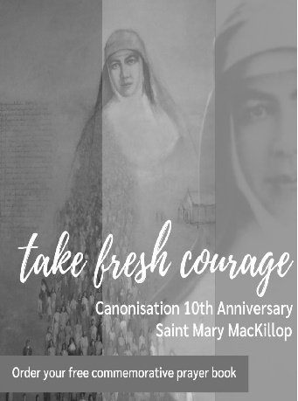
To celebrate the 10th Anniversary of the canonisation of Saint Mary MacKillop we invite you to order your free copy of Encountering St Mary MacKillop in Prayer
The Sisters of Saint Joseph have created a commemorative prayer booklet to inspire us all to “take fresh courage…” as Mary did so often. These prayers share details of her private journey, highlighting Mary’s values and spirit, and offering prayers and blessings for our modern world. To order your exclusive copy please go to: www.marymackilloptoday.org.au/prayer-book or call 02- 89122777

DAILY GOSPEL & REFLECTIONS VISIT pray.com.au
DAILY MASS ON DEMAND VISIT melbournecatholic.org.au/mass

COLLECTIONS
Presbytery $988.00 | Loose$ | Thanksgiving $3018.00

Prayers for the Sick; Alan Crabbe, Pauline Lambert, Will Anderson, Josephine Fenech, Leo Fenech, Ronald Gale, Juan Sanhueza
For the Recently Departed; for the repose of the souls of the faithful departed
Anniversary of Death; Leslie Hart, Christina Kim, Teresa Galassi

ST PIUS X SCHOOL - ENROL NOW FOR 2021 & 2022
Website: spxhw.catholic.edu.au Contact the school 03 94573776 or Email principal@spxhw.catholic.edu.au TOGETHER WE SHINE

